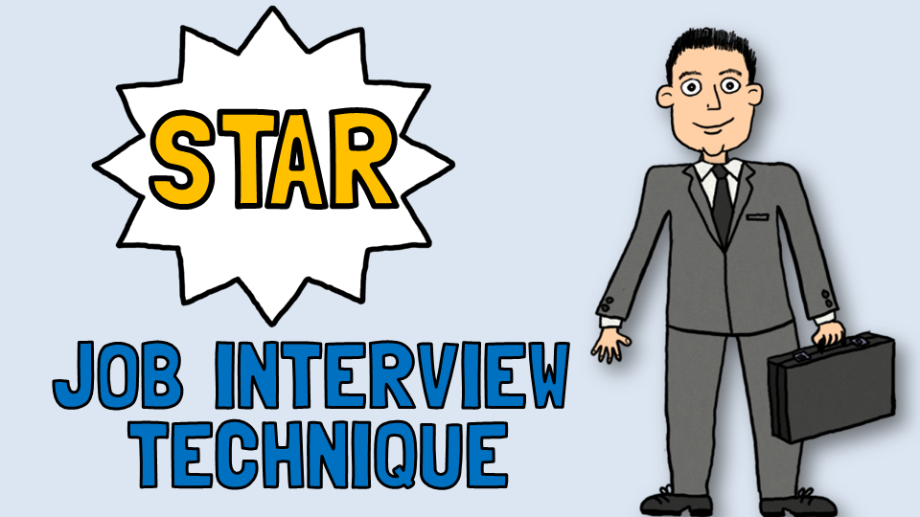

Often not delivering answers to questions with structure, confidence and clarity can really let you down. There’s nothing worse as an employer when the person you’re interviewing waffles on never really answering your questions, there’s no context to what they’re saying and no beginning or end.

Generally interviewers have short attention spans due to the number of questions they have to get through and the different candidates they have to meet, so you need to keep your answers short and concise: create maximum impact in the shortest amount of time.

So how do I make this happen?

We use the STAR technique to give structure to our answers.

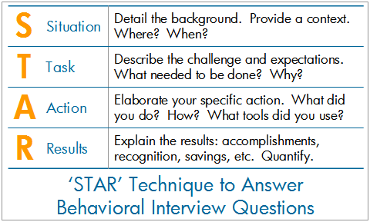

This technique is extremely effective when answering behavioural and situational questions. Interviewers will often ask you to recall a time in your past when you have demonstrated specific skills or had a specific type of experience.

For example. Can you tell me about a time you had to deal with an upset customer? How did you respond?

When you use the STAR frame work and practice it, your answers come across as well-articulated – the fact you’ve used a structure becomes invisible to the interviewer.

You need to create 2 – 3 examples for the types of questions you will be asked and practice them, this is so your responses will be natural and flow on the day without any difficulty.

Here’s an example of the STAR technique in action:

"Describe a situation when you had to deliver excellent customer service following a complaint"

Situation:
"While I was working at ABC company as an Operations Manager a customer called me complaining that they'd waited more than 3 weeks for a reply from our sales team regarding a query on a product they’d purchased”

Task:
"I needed to address the client's immediate query and find out what went wrong in the process."

Actions:
"The first thing I did was apologise to the client, I then got her details and passed them to my Sales Manager, who contacted the client within 30minutes. I investigated why the query hadn't been answered. I discovered that it was a combination of an incorrect cell phone number and it was her old email address that she never checked. I called the client back and personally let her know. I also offered her a product voucher as a gesture of goodwill”

Result:
"The client not only continued to order from us but posted a positive comment about the outstanding customer service she received on our Facebook page"

See the next page for a list of common interview questions to practice.

Basic Interview Questions
- Tell me about yourself.
- Why do you want this job?
- Why should we hire you?
- Why are you leaving your present job?
- What do you know about this industry?
- Why are you interested in our company? What do you know about our company?
- What are your Strengths/Weaknesses?
- What is you greatest failure and your greatest achievement?
- How would you describe your work style?
- When were you most satisfied in your job?
- Tell me about your previous employment and your responsibilities.
- What can you do for us that other candidates cannot?
- What techniques do you use to keep yourself organized?
- What did you like least/most about your previous position?
- What are you passionate about?
- Where do you see yourself in 5/10 years?
- What do you bring that would contribute towards the mission, values and goals of our organization?
- What are your salary expectations?
- What’s the last book you read?
- Why did you leave your last position?
- Do you have any questions for us?
------
Behavioural/Situational Questions:
Prepare a few stories using the STAR-Method that can cover each of the 5 following categories. With the stories fresh in your mind, you will be able to easily adjust them to the specific questions asked to you in an interview.
- Teamwork Oriented
- Problem Solving
- Initiative/Leadership
- Interpersonal Skills
- Challenge/Stress/Pressure

- Provide a time when you were able to identify a complex problem, evaluate the options, and implement a solution. How did the solution benefit your employer?
- Have you ever worked with a difficult team-member or manager, how did you resolve the situation?
- Share an experience you had in dealing with a difficult customer and how you handled the situation.
- Tell me about a time when you felt you were overburdened with work. How did you handle it?
- Have you ever worked in a position where you had to deal with an unhappy customer? Tell me about it.
- Describe a situation where you saw a problem and took steps to fix it.
- Tell me about a time you had to persuade someone to see your side of things.
- Describe your biggest work failure. How did you handle it?
- Could you tell me about a time you were bored on the job?
- Describe a situation where you need information from a co-worker who was slow to respond. What did you do?

Answer the questions using the STAR method.

